**Screenshot of the output:**

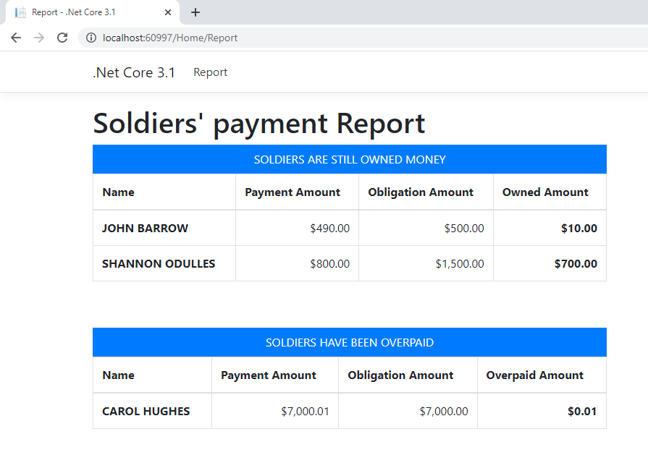

**Follow-up Questions:**

1. **What questions would you ask accounting?**
   1. *How do we receive the input csv file? Should we use secured transfer file? What should we do if we don’t receive the file on time or bad data file?*
   2. *What format of output report should it be? (i.e., Excel, xml, html, …)*
   3. *Who can view the reports?*
   4. *How is the report delivered?*
   5. *Who do we notify when the process generates reports fails? What is impacted if it fails? Should we fix right away? How long should we respond?*
   6. *What time and date should the report run?*
2. **What recommendations would you suggest to accounting?**

*I suggest loading the data into the table or database weekly when we receive the csv file, so the data can be archived safely, and we easily troubleshoot data issue.*

1. **What changes and/or technologies would you use to accomplish this?**
   1. *We would change to use input data from the database/table instead of the csv file and use web reporting tool to display output data.*
   2. *Set user security to view the report*
2. **What technologies would you use to make this information more visually appealing?**

*Web reporting tool such as Cognos could make the information more visually appealing.*